**Quick Start:**

Thanks for purchasing this adapter! To get you started quickly, **PLEASE READ** through and follow these steps:

* Set your +5V to 5.2V before connecting the adapter to your cabinet. Do not exceed 5.4V!
* Please ensure that you have a proper power supply that can deliver at least 10A on the +5V rail. This should include the vast majority of decent arcade and ATX supplies. While it’s not necessary for the Raspberry Pi itself, this adapter requires it to quickly charge the bank of super capacitors for a safe shutdown. Weak power supplies may go into protection mode due to the high current demands of the adapter on startup.
* When attaching your Raspberry Pi, ensure that the GPIO pins line up on both the Pi and the adapter. Failure to do so can result in damage to both devices. No other connection to the Raspberry Pi is necessary.
* While using this adapter, do not use the Pi’s USB ports to power external high current devices like USB hard drives, or force feedback controllers. Doing so may prevent the shutdown from completing fully.
* Do not rest the adapter on a metal surface, even with the power off. The super capacitors can store and release a tremendous amount of energy very quickly, and a short can damage the adapter board and even your surface.
* This adapter is intended to work with open/grounded switches in a typical arcade cabinet. If using a super gun, ensure that any input that is tied to +5V, can only source 10mA of current or less. This should be fine with most super gun devices out there.
* This adapter and the Raspberry Pi are designed to run on 3.3V. Do not connect any of the joystick or switch inputs directly to the power supply’s +5V or +12V output.
* You will need a blank SD card of at least 4GB in size. Your card will be erased during the image install process. Get the fastest SD card possible for the best experience.
* Use the appropriate image for the version of the Raspberry Pi that you’ll be using.
  + RetroPie – for arcade and console gaming. Images are optimized for each version of the Raspberry Pi.
  + Standalone – single arcade game using AdvanceMAME (no consoles). One image supports all Raspberry Pi versions.
  + MiniLauncher – a dozen switchable arcade games with a fast launcher. One image supports all Raspberry Pi versions.
* While the images above will boot in any Pi revision, some images are optimized for the specific hardware (Raspberry Pi version) and may have driver issues resulting in problems with controls, etc…
* Other Raspberry Pi Linux images will not boot with visible video and working controls. Please use the images available on the PJ project page, or create a new one using the provided drivers and configuration information.
* Once the image can boot, you can use the image specific procedure to add your ROMS. The documentation for this can be found on the PJ project website or the RetroPie website if using the RetroPie image.
* Let the adapter deplete its super capacitor reserve before cycling power. Wait until the LEDs turn off completely before turning the power on again. This takes approximately 20-30 seconds after the power has been cut.
* The thermistor near the JAMMA power connector may get hot on startup. This is normal. Avoid touching that area if possible.
* Only the +5V and +12V power source is necessary for proper operation.
* More information can be found on the project page at: http//pcbjunkie.net

**Adapter Overview**

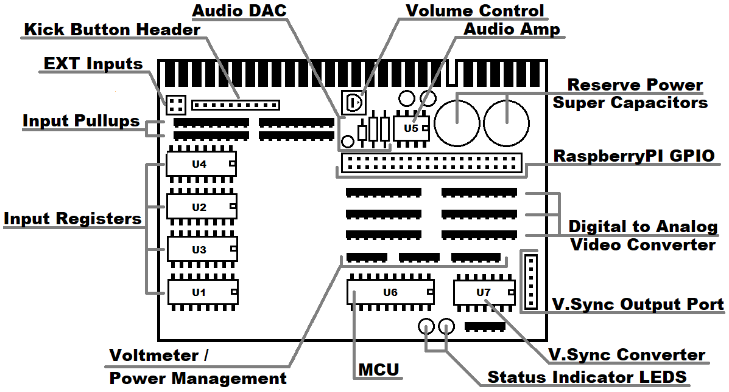

**Input / Output**:

This adapter uses a standard JAMMA interface, with 5 buttons available on the edge connector. Pin orientation is the same as in the diagram above. Greyed out pins are not in use.

|  |  |  |  |  |  |  |  |  |  |  |  |  |  |  |  |  |  |  |  |  |  |  |  |  |  |  |  |  |
| --- | --- | --- | --- | --- | --- | --- | --- | --- | --- | --- | --- | --- | --- | --- | --- | --- | --- | --- | --- | --- | --- | --- | --- | --- | --- | --- | --- | --- |
| **JAMMA EDGE CONNECTOR** | | | | | | | | | | | | | | | | | | | | | | | | | | | | |
| GND | GND | P1 BTN5 | P1 BTN4 | P1 BTN3 | P1 BTN2 | P1 BTN1 | P1 RIGHT | P1 LEFT | P1 DOWN | P1 UP | P1 START | COIN 1 | TEST | VID GND | VID BLUE | VID RED | NC | SPEAKER+ | LOCK 1 | COUNT 1 | KEY | +12V | -5V | +5V | +5V | GND | GND | **TOP SIDE** |
| GND | GND | P2 BTN5 | P2 BTN4 | P2 BTN3 | P2 BTN2 | P2 BTN1 | P2 RIGHT | P2 LEFT | P2 DOWN | P2 UP | P2 START | COIN 2 | TILT | SVC | VID SYNC | VID GREEN | NC | SPEAKER- | LOCK2 | COUNT2 | KEY | +12V | -5V | +5V | +5V | GND | GND | **BOTTOM SIDE** |

Buttons 4-6 can also be connected to the SF2 (Capcom) style kick harness header. Additional 4 inputs (EXT1-4) are available on the EXT header:

|  |  |  |  |  |  |  |  |
| --- | --- | --- | --- | --- | --- | --- | --- |
| **SF2 KICK HARNESS HEADER** | |  | **EXT HEADER (OLD VERSION)** | |  | **EXT HEADER (NEW VERSION)** | |
| PIN | FUNCTION |  | PIN | FUNCTION |  | PIN | FUNCTION |
| 1 | GROUND |  | 1 | EXT1 |  | 1 | EXT1 |
| 2 | GROUND |  | 2 | EXT2 |  | 2 | EXT2 |
| 3 | P1 LOW KICK |  | 3 | EXT3 |  | 3 | EXT3 |
| 4 | P1 MEDIUM KICK |  | 4 | EXT4 |  | 4 | EXT4 |
| 5 | P1 HARD KICK |  | This connector is present on the older version of the adapter (revision 1.5 or below) | |  | 5 | GND |
| 6 | NOT USED |  |  | 6 | +5V |
| 7 | P2 LOW KICK |  |  | New connector allows for easier connection of powered controllers like trackballs and spinners | |
| 8 | P2 MEDIUM KICK |  |  |
| 9 | P2 HARD KICK |  |  |
| 10 | NOT USED |  |  |

**Input Registers**: Each IC is a parallel-in, serial-out shift register. The following diagram shows which inputs are handled by the corresponding Input Register ICs and the direction of bit-shift travel. This chart along with input testing utilities can be used to troubleshoot input problems. Each input is held high at 3.3V by the input pull-up resistor arrays. Logically, U1 and U2 inputs map to Player 1 controls, while U3 and U4 inputs map to Player 2 controls.

|  |  |  |  |  |  |  |  |  |  |
| --- | --- | --- | --- | --- | --- | --- | --- | --- | --- |
| **U1** |  | **U2** |  | **U3** |  | **U4** |  | **MCU** | |
| SERVICE | P1 BUTTON 1 | NOT USED | P2 BUTTON 1 |  |  | |
| TEST | P1 BUTTON 2 | TILT | P2 BUTTON 2 |  | |  |
| COIN 1 | P1 BUTTON 3 | COIN 2 | P2 BUTTON 3 |  |
| MP1 START | P1 BUTTON 4 | P2 START | P2 BUTTON 4 |  |
| P1 UP | P1 BUTTON 5 | P2 UP | P2 BUTTON 5 |  |
| P1 DOWN | P1 BUTTON 6 | P2 DOWN | P2 BUTTON 6 |  |
| P1 LEFT | EXT 1 | P2 LEFT | EXT 3 |  |
| P1 RIGHT | EXT 2 | P2 RIGHT | EXT 4 |  |

**Video:**

**Video Sync:** Initially, video sync signals are generated by the RaspberryPi on pins (3,5) as positive vertical and horizontal sync signals and sent to the conversion IC CD4077 at location U7. In addition to the negative composite sync which is present on the JAMMA edge connector, all other sync options are available on the V.Sync Output Port Header:

|  |  |
| --- | --- |
| **PIN** | **FUNCTION** |
| 1 | POSITIVE HORIZONTAL SYNC |
| 2 | POSITIVE VERTICAL SYNC |
| 3 | POSITIVE COMPOSITE SYNC |
| 4 | NEGATIVE HORIZONTAL SYNC |
| 5 | NEGATIVE VERTICAL SYNC |
| 6 | NEGATIVE COMPOSITE SYNC |

**Video Digital to Analog Conversion:** Video signals are generated by the RaspberryPi on the GPIO and passed through a single step Digital to Analog (DAC) converter resistor arrays (RA5-RA10). Table below outlines which array is responsible for a particular RGB intensity. Higher bit number indicates higher intensity:

|  |  |  |  |
| --- | --- | --- | --- |
| **RESISTOR ARRAY** | **COLOR** | **INTENSITY** | **BITS** |
| RA5 | RED | HIGH | 5,6,7 |
| RA6 | RED | LOW | 3,4 |
| RA7 | GREEN | HIGH | 5,6,7 |
| RA8 | GREEN | LOW | 2,3,4 |
| RA9 | BLUE | HIGH | 5,6,7 |
| RA10 | BLUE | LOW | 3,4 |

**System State**

Status LEDs on the adapter can be used to determine the state of the adapters, JAMMA inputs and the Raspberry Pi:

|  |  |  |  |  |
| --- | --- | --- | --- | --- |
| **STATUS LED** | **STATUS** |  | **COMM LED** | **STATUS** |
| OFF | NO POWER, BAD RASPBERRY PI, BAD PJ MCU, SHORT CIRCUIT |  | OFF | NO POWER, BAD PJ MCU, BAD RASPBERRY PI, SHORT CIRCUIT |
| ON | SYSTEM OK |  | ON | INPUT SWITCH / JOYSTICK/ BUTTON TRIGGERED |
| 2 BLINKS | MCU RESET |  | SLOW BLINKS | SYSTEM OK, COMMUNICATING WITH PI |
| FAST BLINK | POWER DOWN / BROWN OUT DETECTED |  | FAST BLINKS | SYSTEM OK / BOOTUP, WAITING FOR PI |

**Power and Power Monitoring**

The PJ adapter has a built-in voltmeter and is able to monitor your power to ensure power loss or turning off power results in a safe shutdown. This is the only RaspberryPi to JAMMA adapter on the market that allows simply powering off the device without having to run a shut-down procedure in advance. Failure to safely shut down the OS **WILL** eventually corrupt your SD Card filesystem. The on-board super capacitor bank provides about 35 seconds of run time. Voltage measurement is done by the MCU through the following resistor array voltage dividers and reported to the RaspberryPi.

|  |  |
| --- | --- |
| **RESISTOR ARRAY** | **MEASURES** |
| RA11 | JAMMA SIDE +5V, BEFORE SUPER CAPACITOR BANK |
| RA12 | RASPBERRY PI SIDE +5V, AFTER SUPER CAPACITOR BANK |
| RA13 | JAMMA SIDE +12V |